Redundancy Level

While creating storage accounts, there is an option of redundancy level

* Azure has created multiple regions based on geography. Every region has three availability zones which are separated from each other with hundreds of kms
* We have four types of redundant levels

LRS (Locally redundant storage)

* Three copies of file will be stored in same availability zone
* Adv : If any of the data center is failed, we can access it from other data center. As we have copies at three places. Cost is less
* Disadv : If any natural threat which affects entire availability zone, then entire data will be lost

ZRS(Zone redundant storage)

* Copies of data will be stored in multiple zones
* Charges are high
* Better risk mitigation plan

Geo Redundant storage

* 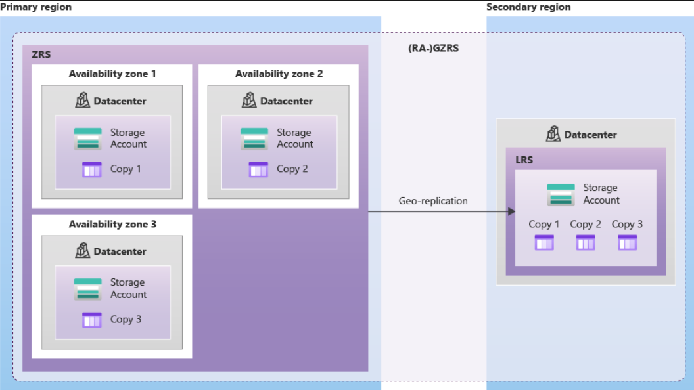

Geo Store redundant storage